Name – Sadula Karthikeya Computer Networks

Roll no – 2420030052

Section no – 2

Exp: 2: Execute the following networking commands like ipconfig, tracert, telnet, netsh, ping, nslookup and netstat in the command prompt with simple topology.

step-by-step guide to opening Cisco Packet Tracer and executing the commands in a simple topology: Step 1: Launch Cisco Packet Tracer:

Double-click the Cisco Packet Tracer icon on your desktop or find it in your applications list to open the program.

Step 2: Create a Simple Network Topology

1. Add Devices:
   * Routers and Switches: Drag and drop a router and a switch from the device list onto the workspace.
   * PCs: Drag and drop two PCs onto the workspace.
2. Connect Devices:
   * Use the Connection tool to connect the devices:

. Connect one PC to the switch using a copper straight-through cable.

· Connect the switch to the router using another copper straight- through cable.

Step 3: Configure Devices

1. Configure the Router:
   * Click on the router.
   * Go to the Config tab.
   * Assign IP addresses to the router interfaces.

Example:

. Interface G0/0: IP address 192.168.1.1, Subnet Mask 255.255.255.0

. Interface G0/1: IP address 192.168.2.1, Subnet Mask 255.255.255.0

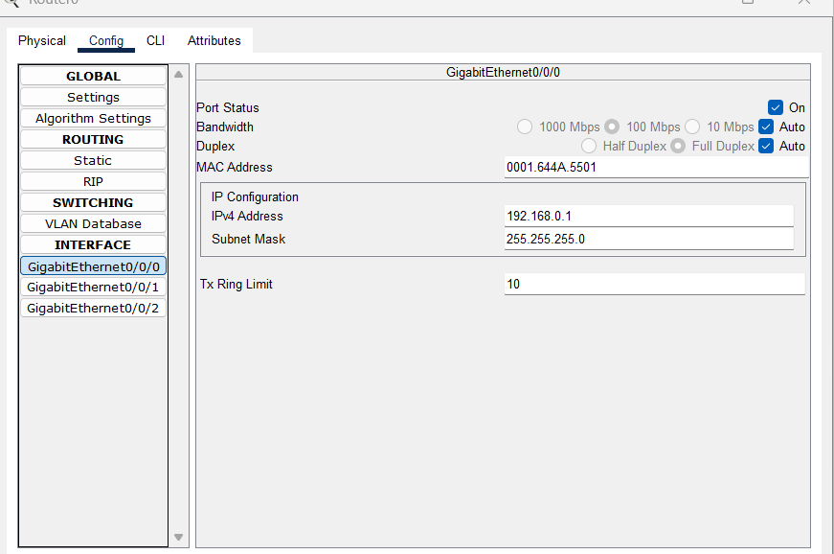

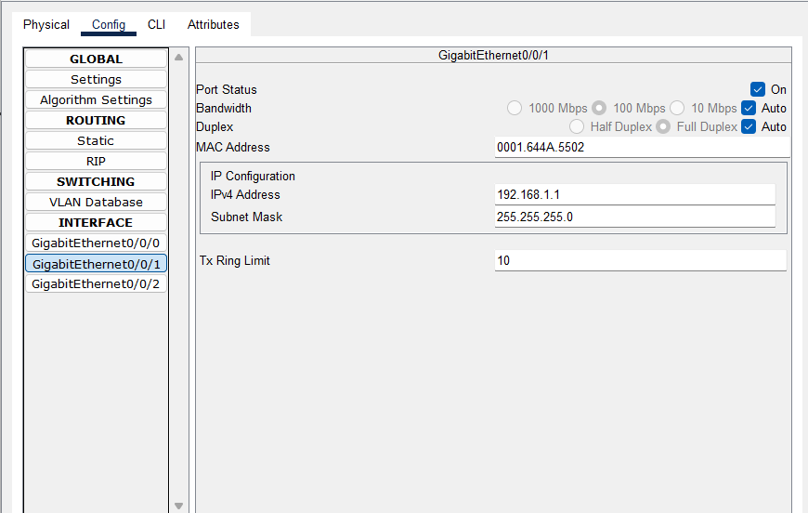

1. Configure the PCs:
   * Click on each PC.
   * Go to the Desktop tab and then IP Configuration.
   * Assign IP addresses to each PC. Example:
   * . PC0: IP address 192.168.1.2, Subnet Mask 255.255.255.0, Default
   * Gateway 192.168.1.1
   * . PC1: IP address 192.168.2.2, Subnet Mask 255.255.255.0, Default
   * Gateway 192.168.2.1

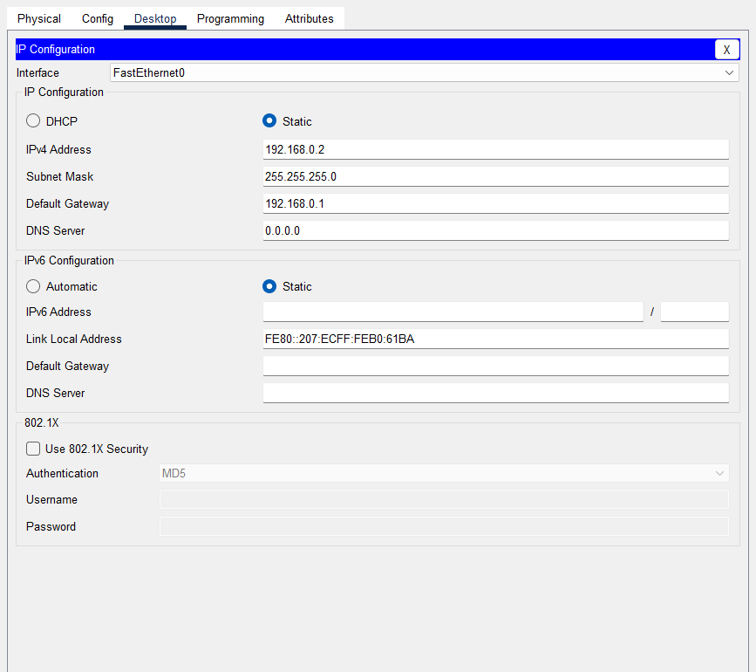

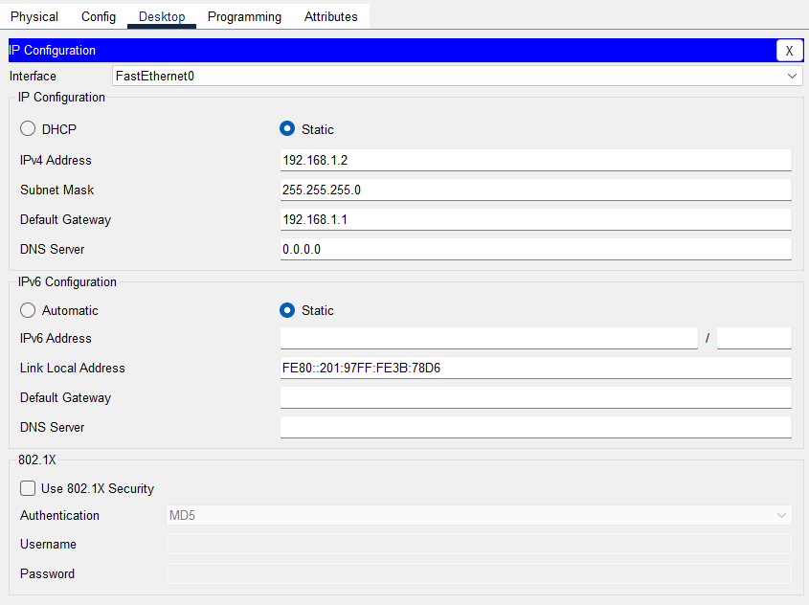

Step 4: Execute Networking Commands

1. Open Command Prompt on a PCO

* Click on a PCO.
* Go to the Desktop tab and open the Command Prompt.

1. ipconfig:

This command displays all current TCP/IP network configuration values and refreshes DHCP and DNS settings.

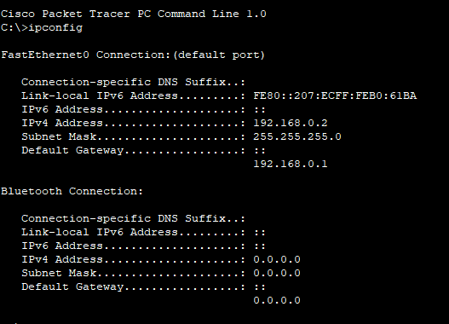

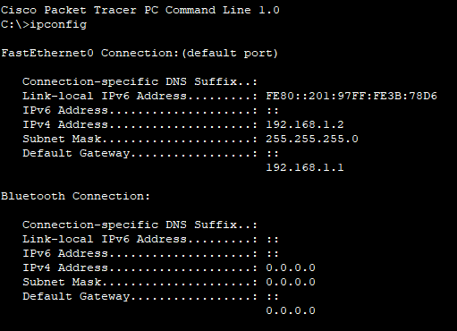

1. tracert:

This command traces the path taken to a destination by sending ICMP Echo Request messages.

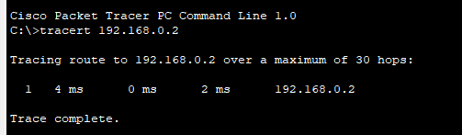

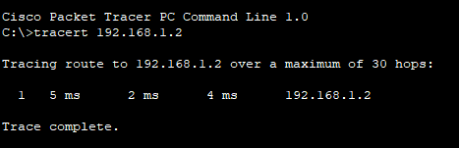

1. telnet:

This command is used for interactive communication with another host using the Telnet protocol.

telnet <destination IP> <port> Configure the Router

1. Assign IP Address:

Click on the router. Go to the Config tab.

Select the interface connected to the switch (e.g., G0/0).

o Assign IP address: 192.168.1.1, Subnet Mask: 255.255.255.0

Router>enable

Router>configure terminal Router(config-if)#line vty 0 4

Router(config-line)#password cisco Router(config-line)#login

Router(config-line)#exit Router(config)#end Router#

%SYS-5-CONFIG_I: Configured from console by console

Router#write memory Building configuration ... [OK]

Router (config-if) line vty 0 4

Router (config-line) #password cisco Router (config-line) #login

Router (config-line) #exit Router (config) #end Router#

&SYS-5-CONFIG I: Configured from console by console

Router#write memory Building configuration ... [OK]

Telnet from PC to Router

1. Open Command Prompt:

o On the PCO, go to the Desktop tab and open the Command Prompt.

1. Execute Telnet Command:

telnet <destination IP> <port>

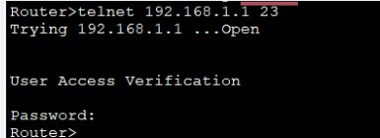

Router>telnet 192.168.1.1 23 Trying 192.168.1.1 ... Open

User Access Verification Password:

Router>

Telnet Security: Telnet is an unencrypted protocol and is not secure. For real-world applications, consider using SSH for secure remote connections.

Enabling Telnet on a Real Router: If using real equipment, make sure Telnet is enabled and the device is configured to accept Telnet connections.

1. Router configuration and Brief Ip Interface

This command is a scripting utility that allows you to display or modify the network configuration of a computer.

Router#show ip interface brief Interface

GigabitEthernet0/0 GigabitEthernet0/1 Vlan1

Router#|

IP-Address 192.168.1.1

192.168.2.1

unassigned

Protocol

OK? Method Status YES manual up

YES manual up

YES unset administratively down down

1. Ping 192.168.2.2

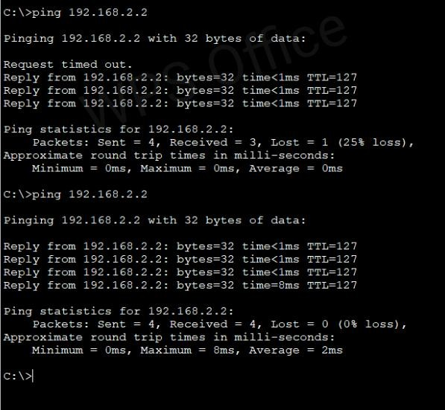

1. nslookup

nslookup [www.google.com](http://www.google.com/)

I This command queries the DNS to obtain domain name or IP address mapping. To use the nslookup command to resolve a domain name to an IP address in

Cisco Packet Tracer, you'll need to ensure that the DNS server is properly configured in your network topology.

1. Add one server (to act as a DNS server).
2. Connect both PCs and the server to the switch using copper straight-through cables.

Configure the DNS Server

1. Assign IP Address:
   * Click on the server.
   * Go to the Config tab and select the FastEthernet0 interface.
   * Assign IP address: 192.168.1.3, Subnet Mask: 255.255.255.0, Default Gateway: 192.168.1.1.

Configure DNS Service:

. Go to the Services tab on the server.

. Sss (e.g., 8.8.8.8)

Use the nslookup Command

1. Open Command Prompt on PCO: Go to the Desktop tab on PCO.

o Open the Command Prompt.

1. Execute the nslookup Command:
2. nslookup [www.google.com](http://www.google.com/)

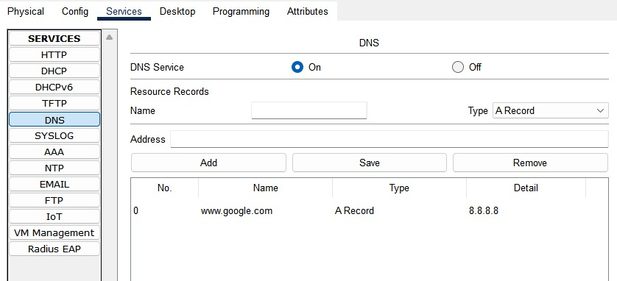

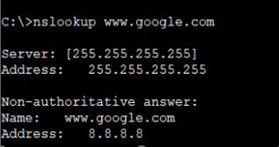

I DNS Server Configuration: Ensure that the DNS server is correctly configured and running.

I DNS Entries: The DNS entry for [www.google.com](http://www.google.com/) should be added to the DNS server with an IP address.

I Network Configuration: Ensure that all devices are correctly connected and configured with appropriate IP addresses, subnet masks, and default gateways.

GÔn IP addhee: 192 188 1 1

Go1 IP adeee:100 180 2 1

PC1 IP akaesa: 192 1A8 12 PC-PT PCO

PC-PT PC1

Defaaul Galexy 192 188 1 1

1. Netstat

This command displays network connections for the Transmission Control Protocol (TCP), routing tables, and a number of network interface and network protocol statistics.

The netstat command is used to display network connections, routing tables, interface statistics, masquerade connections, and multicast memberships.

conmangPS Office

Deteut Ceteway 192.108.2.1

